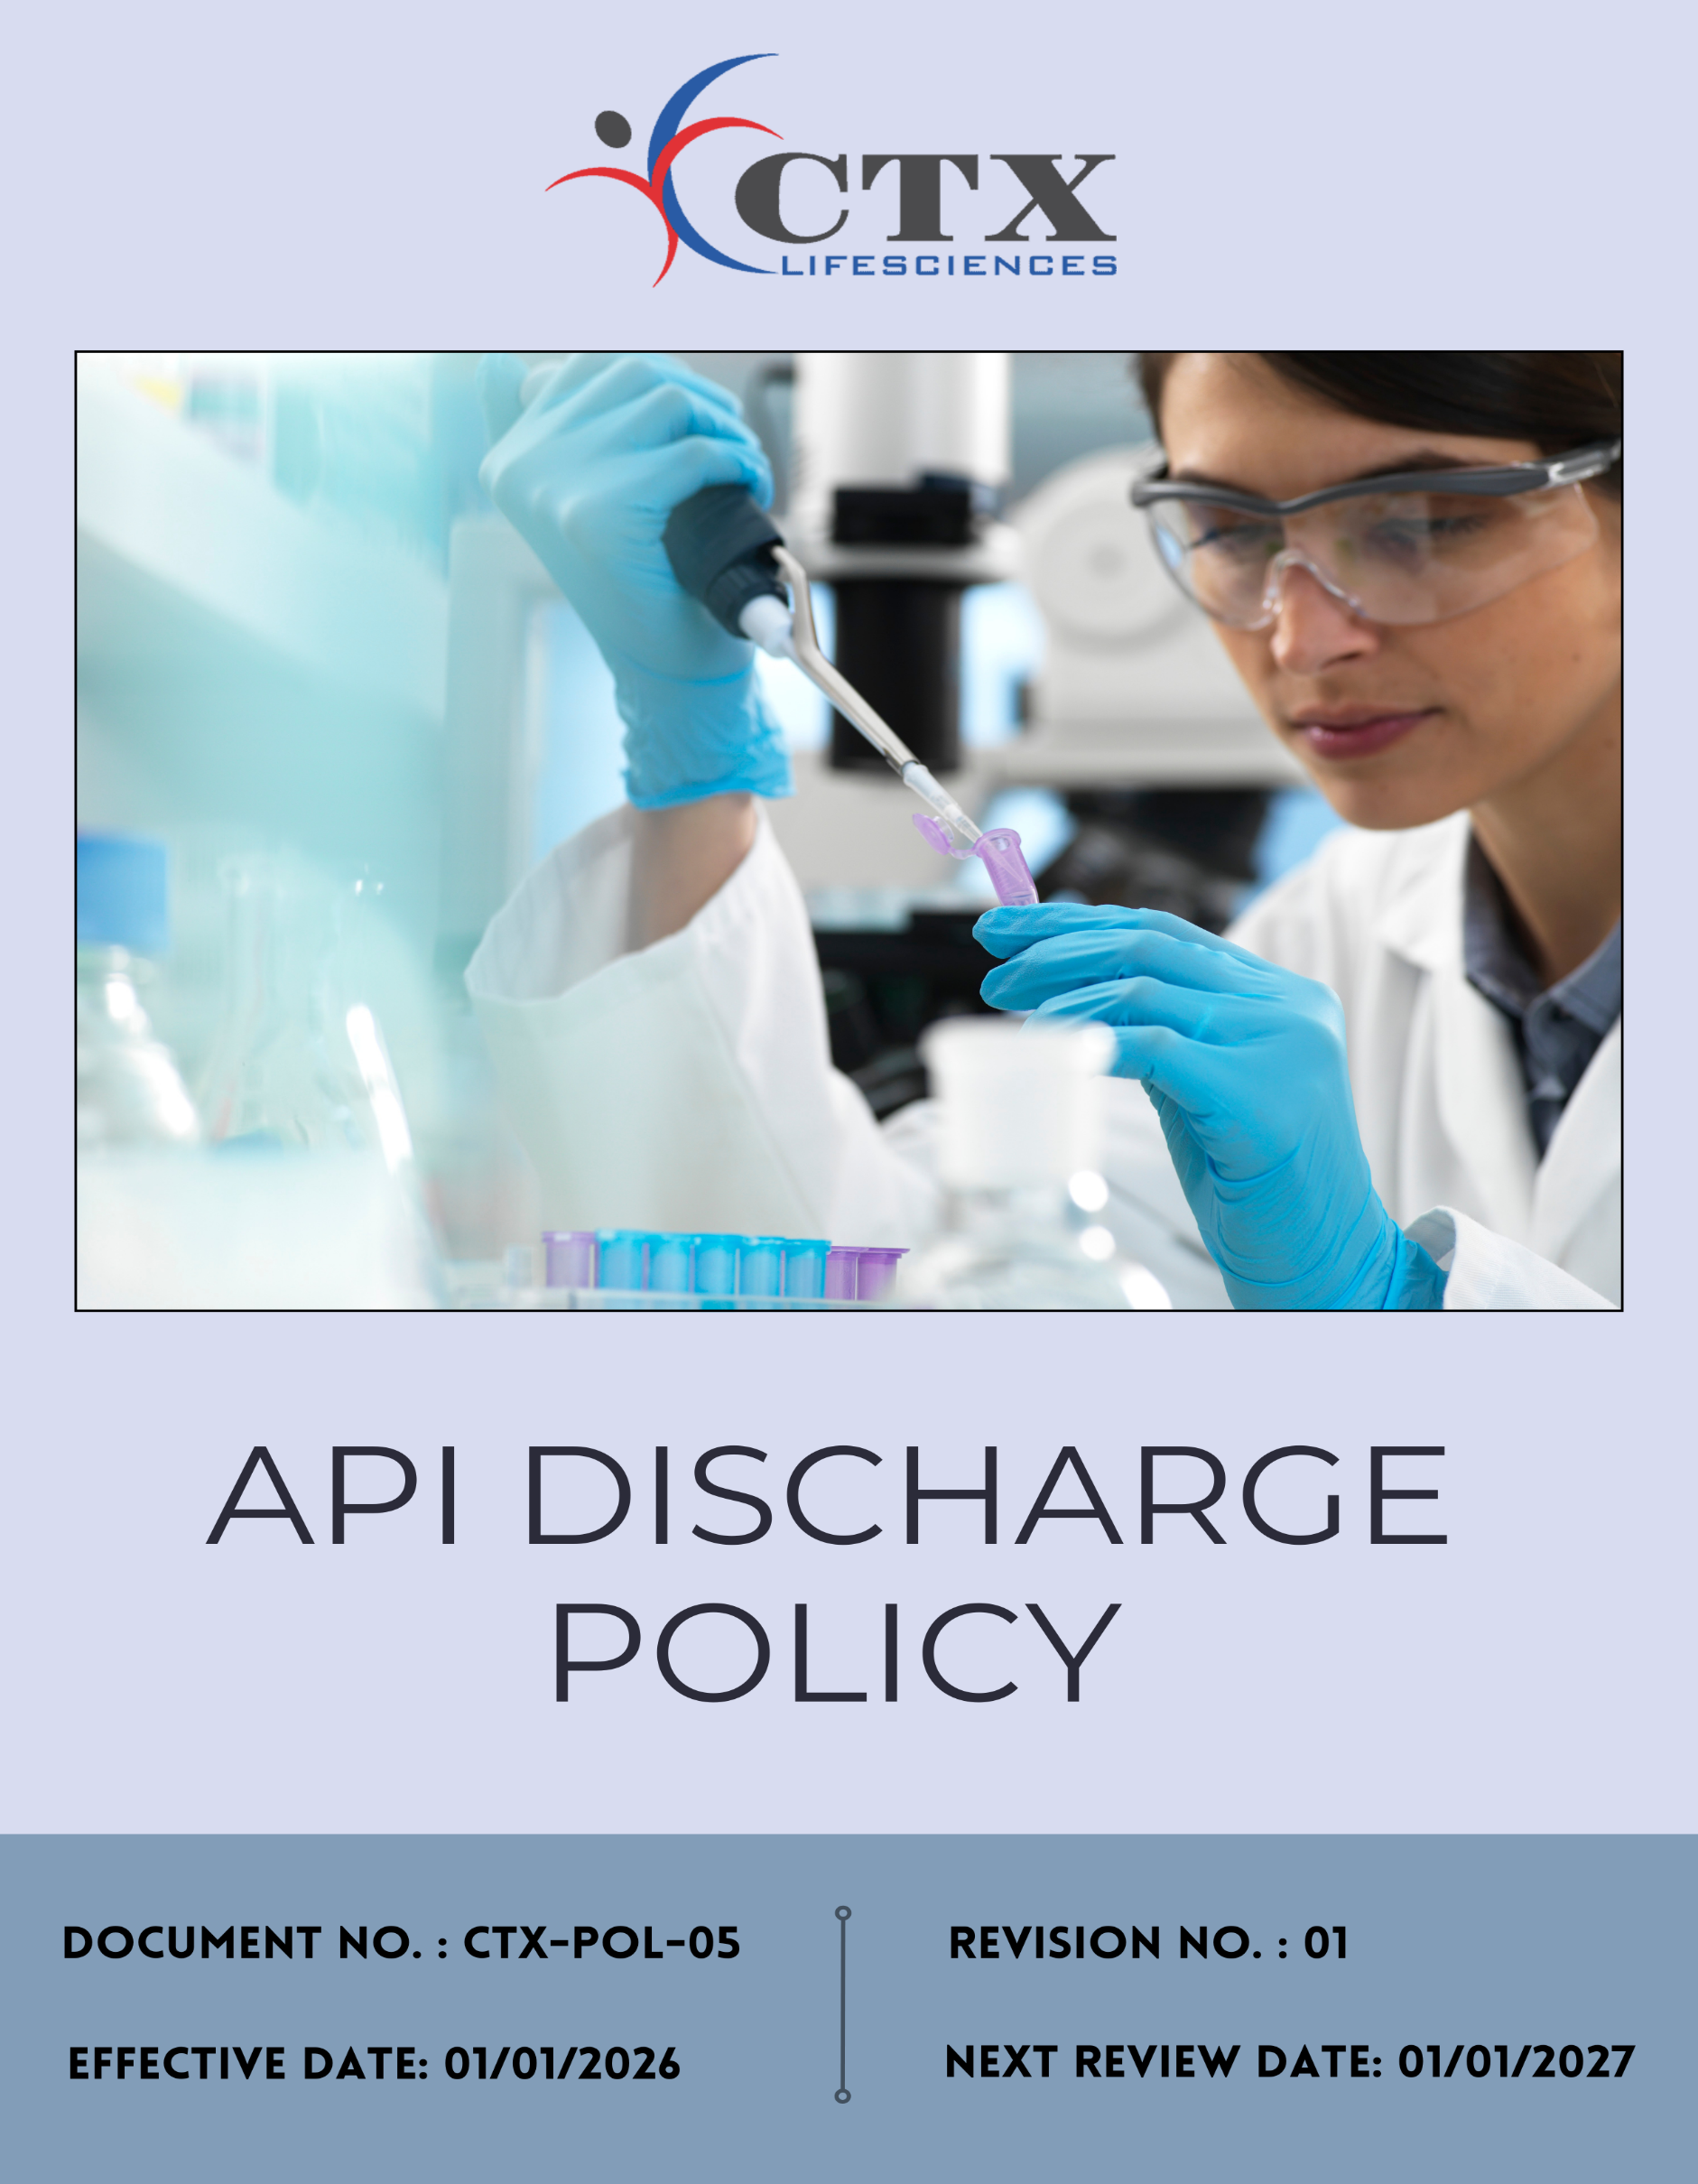
Contents

Preface 3
Policy Declaration 3
Scope 3
Qualitative Objectives 4
Quantitative Targets 4
Alignment with the United Nations Sustainable Development Goals (SDGs) 5
Responsibilities 5
Monitoring, Reporting and Transparency 5
Review Mechanism 6
Employee Acknowledgment Form 7

Preface
CTX Lifesciences Pvt. Ltd., a manufacturer of Active Pharmaceutical Ingredients (APIs) and pharmaceutical intermediates, recognizes the potential environmental risks associated with the discharge of pharmaceutical compounds from manufacturing activities. Responsible management of wastewater and process effluents is essential to prevent environmental contamination and to protect surrounding ecosystems and communities.

This API Discharge Policy outlines the company’s commitment to controlling and minimizing the release of pharmaceutical residues into the environment. Through appropriate wastewater treatment, monitoring, and operational controls, CTX Lifesciences Pvt. Ltd. aims to ensure that effluents generated from its operations are managed in a responsible manner and in compliance with applicable environmental regulations and industry best practices.

Policy Declaration
CTX Lifesciences Pvt. Ltd. is committed to controlling and managing discharges of Active Pharmaceutical Ingredients (APIs) from its operations by ensuring proper treatment and monitoring of wastewater in compliance with applicable environmental regulations. The company strives to minimize environmental impact and promote responsible pharmaceutical manufacturing practices.

Scope
This policy applies to all manufacturing operations and activities of CTX Lifesciences Pvt. Ltd. that may generate wastewater containing Active Pharmaceutical Ingredients (APIs) or related pharmaceutical residues. It covers all departments involved in production, utilities, and environmental management, including processes related to wastewater generation, treatment, monitoring, and discharge from the company’s facilities. The policy also applies to relevant contractors and service providers associated with effluent treatment, handling, and disposal.

Sr. No. | Company Name | Location | Address Details
1 | CTX Lifesciences Pvt. Ltd. | Head Office | Block No. 251–252, Sachin–Magdalla Road, Sachin GIDC, Surat – 394230, Gujarat, India
2 |  | Factory | Block Nos. 251/B, 252/B, 253, 254, 255, 256, 258/B, 276, 277, 278/P, 279, 280, 281, 282, 283/P, 284/P, Sachin GIDC, Near Gabheni Chokdi, Sachin, Surat – 394230, Gujarat, India

Qualitative Objectives
- To prevent and minimize the discharge of Active Pharmaceutical Ingredients (APIs) and related residues into the environment.
- To ensure effective treatment and responsible management of wastewater generated from manufacturing operations.
- To maintain compliance with applicable environmental regulations and discharge standards.
- To strengthen monitoring, control, and management systems for wastewater and effluent handling.
- To promote continuous improvement in wastewater treatment practices and environmental performance.

Quantitative Targets
CTX Lifesciences Pvt. Ltd. has established the following targets with FY 2022–23 as the baseline year to strengthen the management and reduction of Active Pharmaceutical Ingredient (API) discharges, with targets to be achieved by FY 2029–30.
- Reduce API residues in wastewater effluents by 20% by FY 2029–30 through optimization of the Effluent Treatment Plant (ETP), adoption of improved treatment technologies, and strengthening process controls to minimize API losses.
- Implement real-time monitoring systems for 100% of effluent discharge points by FY 2029–30, with quarterly verification to ensure continuous compliance with discharge standards.
- Ensure 100% safe handling and disposal of off-specification or expired API materials by FY 2025–26 through approved waste management and disposal protocols.

Alignment with the United Nations Sustainable Development Goals (SDGs)
The sustainability objectives and performance targets align with the following Sustainable Development Goals (SDGs):
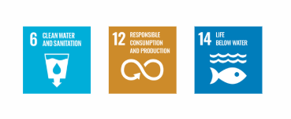

Responsibilities
- Senior Management: Approves the policy and ensures adequate resources for effective implementation.
- EHS Team: Implements the policy, monitors wastewater quality, and ensures compliance with environmental regulations.
- ETP Team: Operates and maintains the Effluent Treatment Plant and monitors treatment efficiency.
- All Employees: Comply with the policy and report any incidents related to wastewater or API discharge.

Monitoring, Reporting and Transparency
CTX Lifesciences Pvt. Ltd. ensures regular monitoring of wastewater generated from its manufacturing operations to control the discharge of Active Pharmaceutical Ingredients (APIs). Key effluent parameters such as pH, COD, BOD, TDS, and other relevant indicators are routinely tested to verify the effectiveness of the Effluent Treatment Plant (ETP) and ensure compliance with applicable environmental discharge standards. Monitoring results are reviewed by the EHS team and reported to management to support effective environmental management and continuous improvement in wastewater treatment practices.

Review Mechanism
This API Discharge Policy will be reviewed annually to ensure its continued relevance, effectiveness, and alignment with applicable environmental regulations, industry best practices, and the operational requirements of CTX Lifesciences Pvt. Ltd. The review will be coordinated by the Environment, Health and Safety (EHS) team in consultation with the Production, Utilities, and senior management teams. Any significant updates or revisions to the policy will be subject to management approval and communicated to relevant employees and stakeholders.

Effective Date | : 01.01.2026
Next Review Date | : 01.01.2027
Revision No. | : 01

Approved By:

Employee Acknowledgment Form
I acknowledge that I have read and understood the API Discharge Policy of CTX Lifesciences Pvt. Ltd. and recognize the company’s commitment to responsible management of Active Pharmaceutical Ingredient (API) discharges and wastewater generated from its operations.
I understand that effective management of API discharge requires compliance with environmental regulations and responsible handling of wastewater and pharmaceutical materials to prevent environmental contamination.
By signing this document, I commit to adhering to the requirements of this policy and to reporting any concerns related to API discharge through the appropriate channels.

Employee Name | : _________________________
Employee ID | : _________________________
Department | : _________________________
Signature | : _________________________

